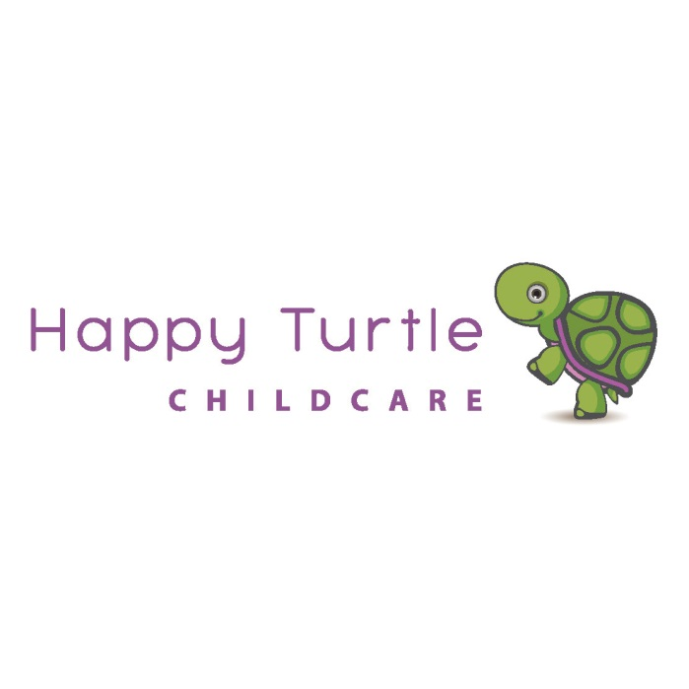
Welcome| We wish to welcome you to our family operated childcare centre which consists of an open door policy. You and your family are welcome to visit our centre at any time. Our Parent Handbook explains imperative information you will need to be responsive of whilst your child is in attendance at our Service.
We strongly recommend you read the provided information and ask questions to confirm your understanding of how the Service operates. You will be required to sign and return the form on the last page of the handbook to confirm you have read and understand the information you have been given in your enrolment pack.
We have an open door policy. You and your family are welcome to visit our Service at any time.

Happy Turtle Childcare Centre Philosophy
Our Centres philosophy reflects our values and beliefs. At Happy Turtle Childcare Centre we endeavour to create a setting in which children will find comfort and security,
We aim to provide children and their families with atmosphere that is warm, welcoming, nurturing and enjoyable. We offer a safe and supportive environment where children are valued and encouraged to develop to their full potential as they progress through their early years.
We aim to achieve this by…..In relation to the child; we believe...
- Children are capable and resourceful involved learners who are active contributors to their own learning.
- Children learn through play, learning can occur anywhere at any time. Children’s learning is increased when engaged in interest based, meaningful experiences.
- Children need to be valued as individuals within the context of their family and their community.
- Children can develop confidence and positive self-esteem through a supportive and secure environment.
- All children despite gender, race, religion or ability have the right to access quality childcare.
- Respectful relationships.

Therefore we...

- Implement a child- centred based upon the principles and practices outlined in the Victorian Early Years Learning and Development Framework and the Early Years Learning Development Outcomes.
- RIE – Respectful
- Strive to empower children, by using their thoughts and ideas to develop the program.
- Promote each child’s confidence and positive self image through a range of provisions, experiences and opportunities that build upon their understandings, skills, values and sensitivities and promote success
- Implement an inclusive approach to positively support children’s growth of identity, self esteem and critical thinking.
- Encourage each child to reach their full potential in accordance with their individual ability.
In relation to families; we believe...
Trust, respect and collaboration form the basis of strong partnerships between families and staff.
- Families, children and staff form a caring community.
- Family involvement is integral to high quality curriculum

Therefore we...

- Are committed to open and constructive communication with families.
- Strive to have empathy and be responsive to family needs, and provide support when required.
- Encourage families to engage in meaningful participations within the curriculum.
- Strive to ensure families feel welcome and belong to our service.

In relation to the curriculum; we believe...

- Children learn through play collaboration and communication with other children and through interacting with the environment.
- Children need opportunities to practice and consolidate their skills in key learning areas including: language and literacy; mathematics, science and social and emotional development and work towards learning outcomes.
- A rich, stimulating and nurturing environment has the potential to stimulate imagination, promote creativity and enhance aesthetic development.
- Diversity within our centre, families, staff and wider community should be respected and celebrated and that we can play role in fostering and developing a social conscience among children with a view to addressing social inequities.

Therefore we...

- Implement a flexible program that is responsive to the evolving nature of the early childhood environment and that provides for different learning styles.
- Make observations of children and document their work to form the basis of the program
- Use both indoor and outdoor environment to en with courage the children ability to observe, explore, investigate, imagine, make choices and problem solve.
- Provide attractive, well maintained play areas, with the thoughtful use of furnishing and display.
- Introduce children to a wide range of social and cultural experiences, family types and different ways of doing things so they will learn to value diversity, lean to accept challenges they may face and become fully realised members of society.

In relation to educators; we believe...

- In employing educators who are committed to working for the best interest of children and families.
- That each educator brings fundamental, personal qualities to the centre’s environment such as empathy, respect, warmth and passion for learning.
- In a strong committed to, professional planning, documenting, analysing and responding to children’s learning.

Therefore we...

- We provide opportunities for educators to share in decision making and to obtain feedback.
- Provide a safe and comfortable working environment with release time for programming and other duties.
- Provide ongoing professional development for educators.
Service Information
Our Service caters for children aged 6 weeks to 6 years. We are open from 7.00am to 6.00pm Monday to Friday, (51 weeks of the year) we are closed from 23rd December each year until the 2nd of January and closed on Victorian public holidays.
We have 4 classrooms:
6 weeks -2 year old room – Hatchlings
2-3 year old room - Toddlers
3-4 year old room - Pre Kindy
4-6 year old room - Kindy Explorer

Contact Information
- Phone: 03 5021 2933
- Email: info@happyturtlechildcare.com
- Website: www.happyturtlechildcare.com
- Face book: @happyturtlechildcare.com
- Owner & Managers: Frank and Cathy Marziano
- Service Director: Cathy Marziano
- Nominated Supervisors: Cathy Marziano & Rebecca Leersen
- Assistant Director: Rebecca Leersen
- Educational Leader: Sharon Cufari

Fees
Our full fee is: $100.00 per day, before Child Care Subsidy (CCS) has been applied.
Families are required to complete the online Child Care Subsidy assessment via myGov website prior to starting at the Service. This will determine your eligibility and level of Child Care Subsidy entitlement.
On enrolment we will need the CRN of the person linked with the child, as well as the child’s CRN so we can confirm, and register attendance and ensure that you are receiving the appropriate subsidy.

Child Care Subsidy (CCS)
Child Care Subsidy is a means-tested subsidy paid directly to the Service as a fee reduction. There are 3 factors that will determine a family’s level of Child Care Subsidy, which include:
- Combined Family Income
- Activity Test for both parents
- Service Type
Transitioning to Child Care Subsidy requires families to provide information and confirm current details by using your Centrelink online account through myGov. Here you will be asked to provide your combined family income estimate for the financial year, hours of recognised activity including work, training, study and volunteering and the type of child care your family uses.
Allowable Absences

You can be paid for any absence from approved care your child attends for up to 42 days per child per financial year. Additional absences beyond 42 days for certain reasons may be approved and paid. Please talk to us about the additional absences.
Public holidays will be counted as an absence if the child would normally have attended the Service on that week day, and fees have been charged for that day for the child. You can access your child’s absence record on your online statement by selecting 'View Child Care Details and Payments' on your Centrelink online account. You can also do this using the Kidsxap mobile app
Regulatory Authorities

Our Service complies with the National Quality Framework (NQF) including the National Quality Standard (NQS), the Early Years Learning Framework (or other Approved Framework) and the National Regulations (Education and Care Services National Regulations).
Our Service is regulated by the new national body for early education and care – the Australian Children’s Education and Care Quality Authority (ACECQA) as well as the state licensing department in our State/Territory. To contact our Regulatory Authority, please refer to the contact details below:

Department of Education & Training
P. O. Box 442 Bendigo
Victoria 3550
Telephone: 03 5440 3111
www.education.vic.gov.au
Service Closing Time and Late Fees
Please be aware the Program closes at 6:00pm. In accordance with National Regulations and licensing, we are not permitted to have children in the service after 6:00pm. A late fee is incurred for children collected after 6.00pm.

The fee is $15:00 per child, after 6:00pm. If you collect your child at 6:05pm this will incur an extra fee of $15:00. If you collect your child at 6:15pm this will incur an extra fee of $30:00. This will be added to your next account. The late fee is strictly adhered to, as two staff members are required to remain at the program until all children are collected.

If we are unable to contact either the parent or a person nominated by the parent on the enrolment form to arrange collection of the child/children within a half hour of the Service closing, 6:30pm then we will contact the Department of Education and Training and the Police to take responsibility of your child.
Confidentiality

We are committed to protecting your privacy. We support and are bound by privacy laws to ensure strict confidentiality is maintained.
To plan programs with you we need to collect information from you. This information helps us to assess and plan programs in partnership with you. We do not disclose personal information about you or your child to other people or organisations without your consent, unless we are required to do so by law. We do not ask for personal information about you or your child from other professionals or organisations without your consent. You can look at the information in your child’s file at any time, or request a copy of information in the file.

Service Policies and Procedures

You will find a copy of our Service policies and procedures in the office. We expect our staff and families to adhere to our policies and procedures at all times to ensure we maintain compliance and abide by the National Law and Regulations.
Educators cannot make exceptions for individuals unless the Nominated Supervisor or Management do so on account of serious and/or unusual circumstances.

We are constantly reviewing our policies and procedures and ask for staff and family participation to ensure our policies and procedures adhere to family’s needs and meet required regulations. Your involvement helps us to improve our Service and may lead us to change our policies and procedures.

Educational Program
We follow the Early Years Learning Framework as per our programming policy. This is Australia’s ﬁrst national Early Years Learning Framework for early childhood educators. The aim of this document is to extend and enrich children’s learning from birth to Five years and through the transition to school.
We are committed to providing a developmental and educational program, which caters for each child’s individual needs, abilities and interests. Our program will continue to develop as we use the relationships children have with their families and communities, working in partnership with parents, to ensure each child’s knowledge, ideas, culture, abilities and interests are the foundation of our programs.

We encourage children to be responsible for their own learning through choices in experiences, interests and routine. We use conversations, actions and play as the basis for teaching which involves the children being partners in teaching by seeking out ideas, opinions, thoughts and questions. We encourage children in promoting their independence and self-help skills by assisting within the routine and involving the children in interest based projects to further enhance their learning and knowledge. We value children and family input and encourage family involvement in order to gather a comprehensive and holistic view of the child.

We know that children learn effectively through play and Educators who are diligent in their responsiveness to each child support this. Applying strong intentional teaching practices will provide the children with an authentic and meaningful learning environment that challenges, supports and nurtures a child’s development.

If we as Educators have any areas of concern, we will inform you and advise where help may be pursued, e.g. speech therapist. We understand this is a sensitive topic and it is always your decision to follow this up. Educators are willing to discuss any aspect of learning and development with parents.

Please list what skills talents, interest and culture that you and your family (not forgetting grandparents) are able to share with the Service.

We encourage our family's and extended family's to apply for their Working With Children's Check so you may be involved in excursions and incursions that we have for our children.

Early Years Learning Framework
Fundamental to the Framework is a view of children’s lives as characterised by belonging, being and becoming. From before birth children are connected to family, community, culture and place. Their earliest development and learning takes place through these relationships, particularly within families, who are children’s ﬁrst and most inﬂuential educators. As children participate in everyday life, they develop interests and construct their own identities and understandings of the world.

BELONGING
Experiencing belonging – knowing where and with whom you belong – is integral to human existence. Children belong ﬁrst to a family, a cultural group, a neighbourhood and a wider community. Belonging acknowledges children’s interdependence with others and the basis of relationships in deﬁning identities. In early childhood, and throughout life, relationships are crucial to a sense of belonging. Belonging is central to being and becoming in that it shapes who children are and who they can become.

BEING
Childhood is a time to be, to seek and make meaning of the world. Being recognises the signiﬁcance of the here and now in children’s lives. It is about the present and them knowing themselves, building and maintaining relationships with others, engaging with life’s joys and complexities, and meeting challenges in everyday life. The early childhood years are not solely preparation for the future but also about the present.

BECOMING
Children’s identities, knowledge, understandings, capacities, skills and relationships change during childhood. They are shaped by many different events and circumstances. Becoming reﬂects this process of rapid and signiﬁcant change that occurs in the early years as young children learn and grow. It emphasises learning to participate fully and actively in society.

Outcome 1: Children have a strong sense of identity
Children feel safe, secure, and supported
Children develop their emerging autonomy, inter-dependence, resilience and sense of agency
Children develop knowledgeable and confident self-identities
Children learn to interact in relation to others with care, empathy and respect

Outcome 2: Children are connected with and contribute to their world
Children develop a sense of belonging to groups and communities and an understanding of the
reciprocal rights and responsibilities necessary for active community participation
Children respond to diversity with respect
Children become aware of fairness
Children become socially responsible and show respect for the environment

Outcome 3: Children have a strong sense of wellbeing

Children become strong in their social and emotional wellbeing
Children take increasing responsibility for their own health and physical wellbeing

Outcome 4: Children are confident and involved learners
Children develop dispositions for learning such as curiosity, cooperation, confidence, creativity, commitment, enthusiasm, persistence, imagination and reflexivity
Children develop a range of skills and processes such as problem solving, enquiry, experimentation, hypothesising, researching and investigating
Children transfer and adapt what they have learned from one context to another
Children resource their own learning through connecting with people, place, technologies and natural and processed materials

Outcome 5: Children are effective communicators
Children interact verbally and non-verbally with others for a range of purposes
Children engage with a range of texts and gain meaning from these texts
Children express ideas and make meaning using a range of media
Children begin to understand how symbols and pattern systems work
Children use information and communication technologies to access information, investigate ideas and represent their thinking

